Synthesis and characterization of… Arial Bold 12 pts

John Brown Arial 12 pts

University, Green St. 32, 01-372 Town, Country Arial Italic 10 pts
e-mail:

The acid treatment of the MOR zeolite extracted aluminum atoms from the zeolite framework, leading to a significant increase in its Si/Al molar ratio from 15 to 25 [1].

(Abstract 1 A4 page, Arial 11 pts, all margins 2.5 cm, space between lines 1.15.)

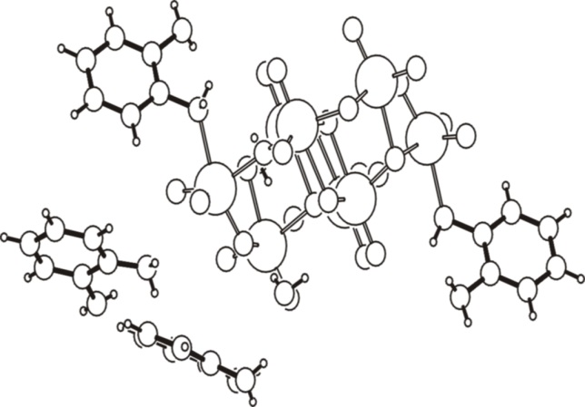

Fig. 1. Figure caption. Arial 10 pts

References
1. J. Brown, J. Catal. 72 (2005) 467 Arial 10 pts
2.
3.
4.

Acknowledgements: We thank National Science Foundation for….(Arial 10 pts)

Please do not use: the section break or the page break, and automatic numbering.

Please label a file containing your abstract as:

Author1, Author2_poster(oral, flash-oral)_No.(of a section chosen)

