**Synthesis and characterization of…** **Arial Bold 12 pts**

John Brown Arial 12 pts

*University, Green St. 32, 01-372 Town, Country Arial Italic 10 pts*

*e-mail:*

The acid treatment of the MOR zeolite extracted aluminum atoms from the zeolite framework, leading to a significant increase in its Si/Al molar ratio from 15 to 25 [1].

(Abstract **1 A4 page**, Arial 11 pts, all margins 2.5 cm, space between lines 1.15.)

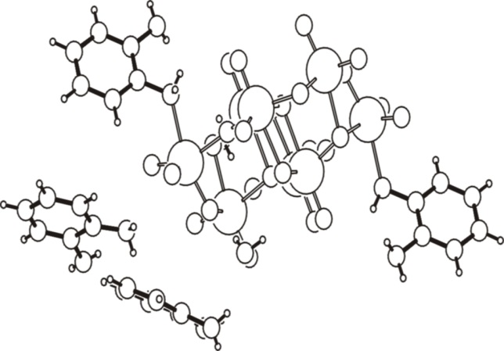

Fig. 1. Figure caption. Arial 10 pts

**References**

1. J. Brown, J. Catal. 72 (2005) 467 Arial 10 pts

2.

3.

4.

*Acknowledgements:* We thank National Science Foundation for….(Arial 10 pts)

**Please do not use: the section break or the page break, and automatic numbering.**

**Please label a file containing your abstract as:**

**Author1, Author2_poster(oral, flash-oral)_No.(of a section chosen)**